PostgreSQL Installation
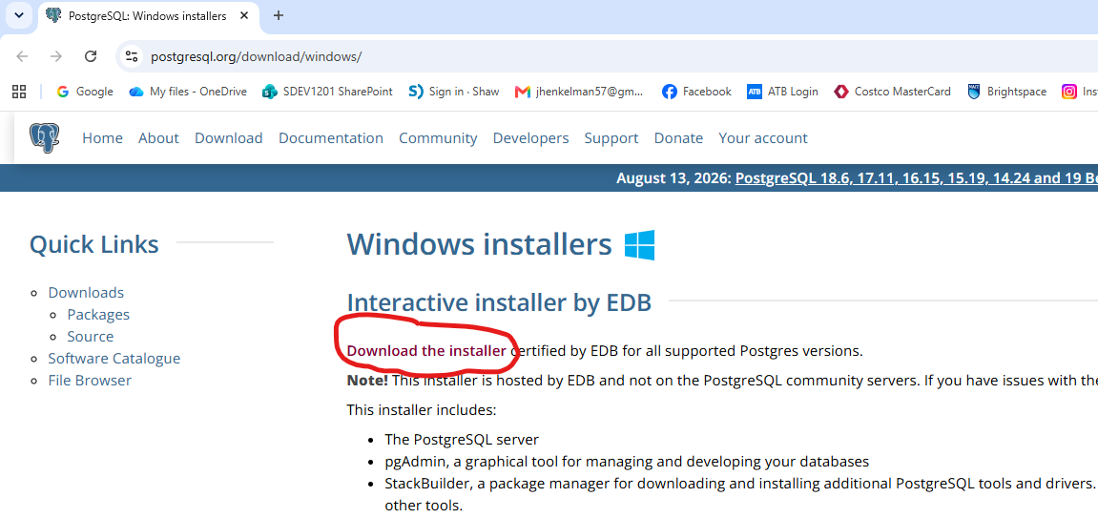
A new window will appear; choose what OS you need.
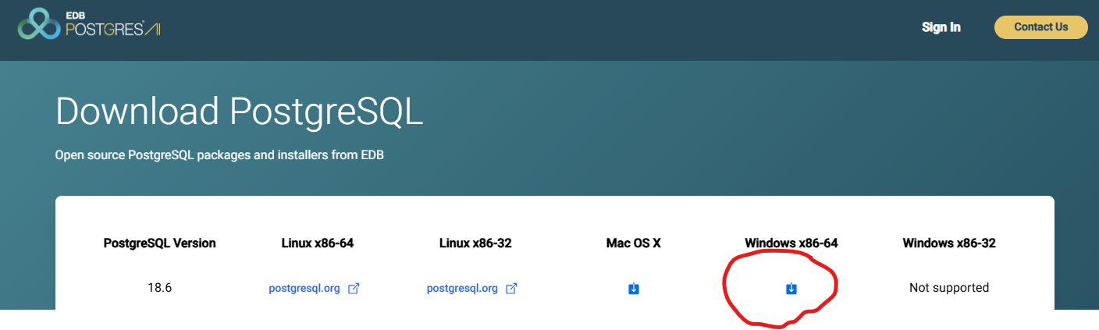
Run the installer “postgresql-18.6-1-windows-x64.exe” after it downloads.
Click Yes to “Do you want to allow this app to make changes to your device?”.

PostgreSQL Installation (Windows)
Leave the default values unless you have a very specific reason to change the given value.
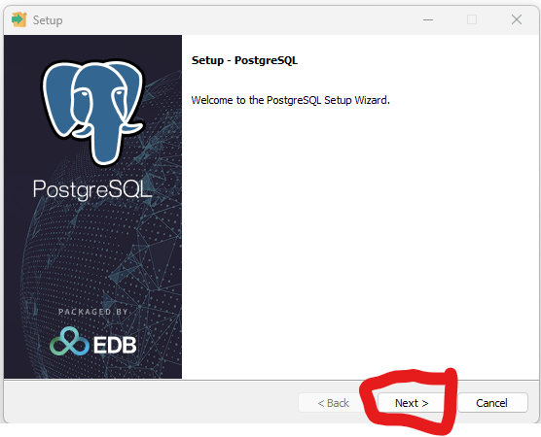

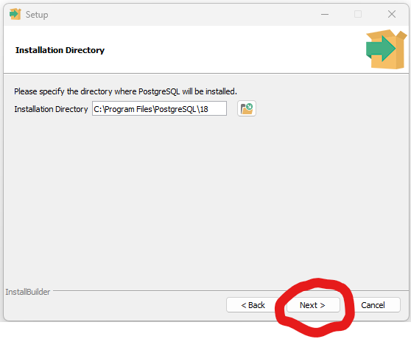
Uncheck Stack Builder
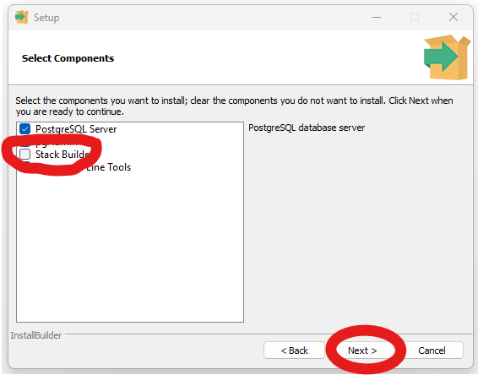

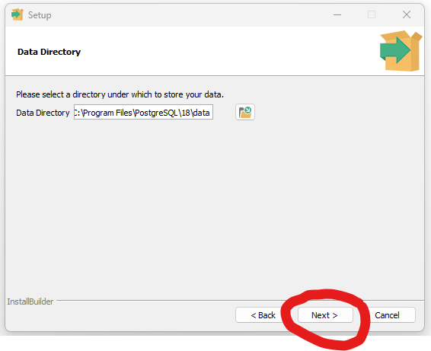

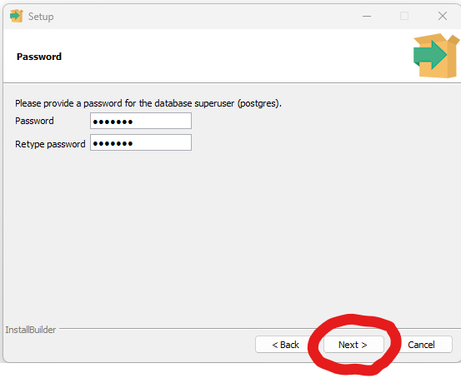
Make sure you keep the password safe, otherwise you will have to uninstall and reinstall.
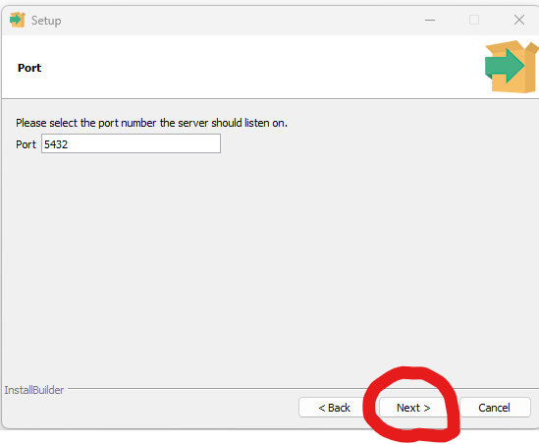

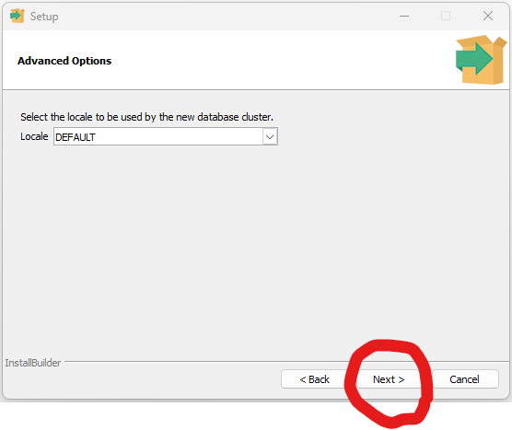

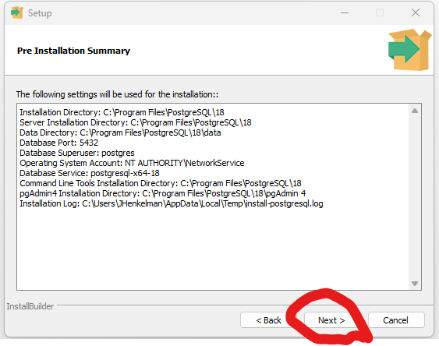

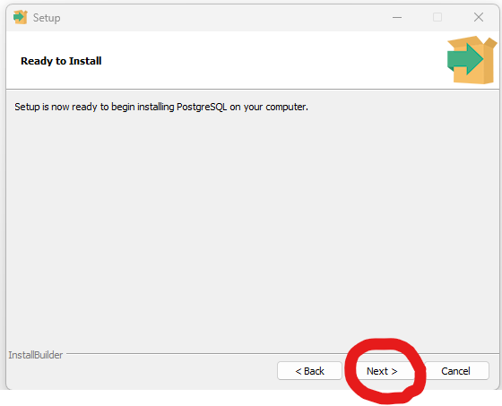
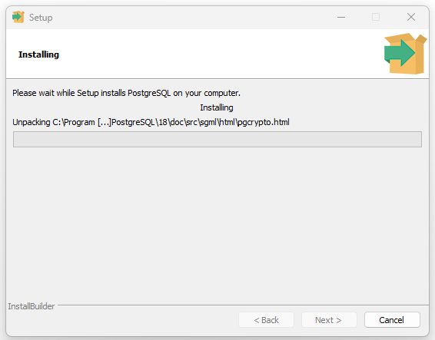
Installing…

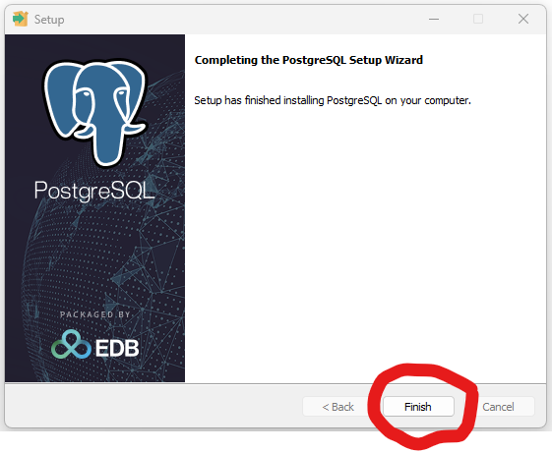

The installation is now complete.

Search for and Open pgAdmin4

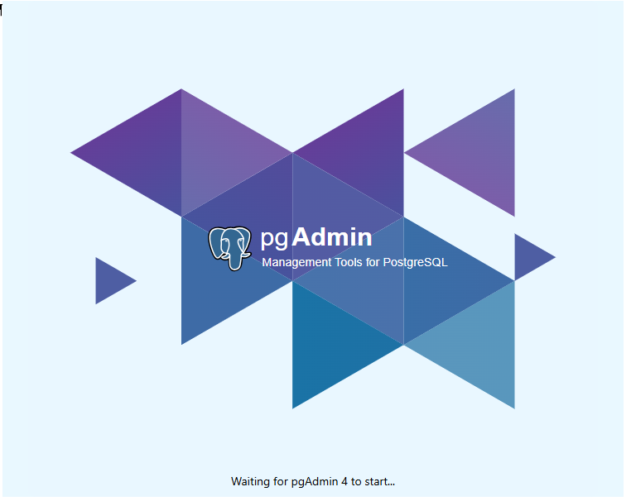

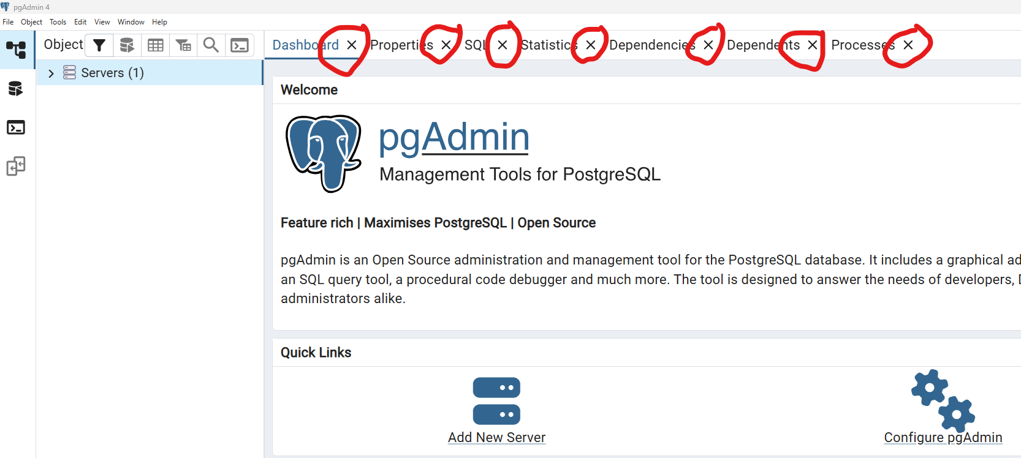
To clean up the look of pgAdmin, you can close all the default tabs (highlighted in red) to make it easer to see what is going on.

When you open pgAdmin for the first time, you need to enter your server password. You can save the password or choose to enter the password each time you open pgAdmin.
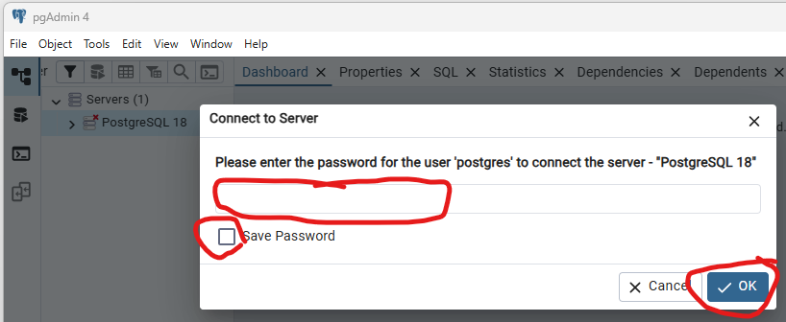

Click on Servers. If this is the first PostgreSQL installation, you will only have PostgreSQL 18
Click on PostgreSQL 18, Click on Databases you should see the default “postgres” database you have available to you. You can add as many databases as you wish: right click PostgreSQL 18, Create, Database. Type in the database name and click Save
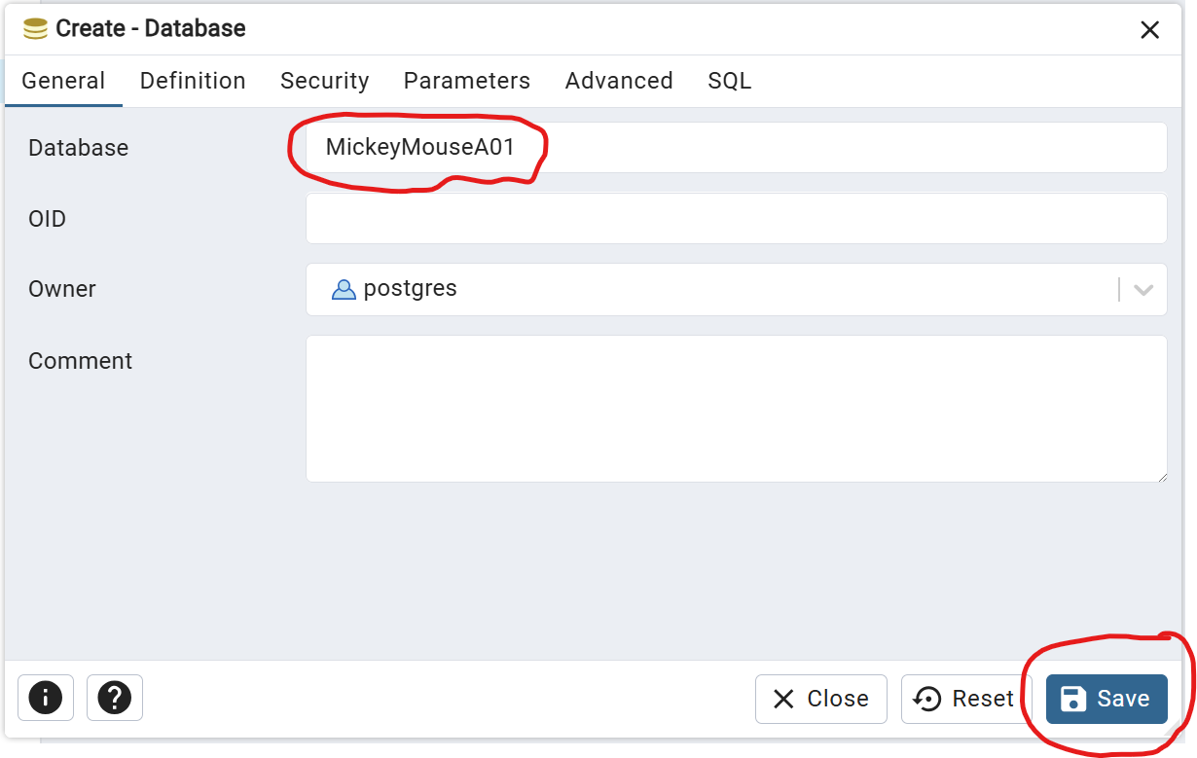

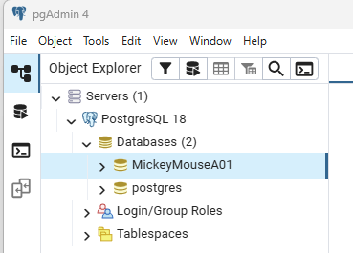

I created a database called MickeyMouseA01 as an example

Right click on the database you want to use and click Query Tool, or use Alt +Shift + Q.
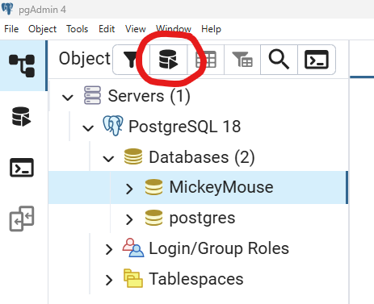

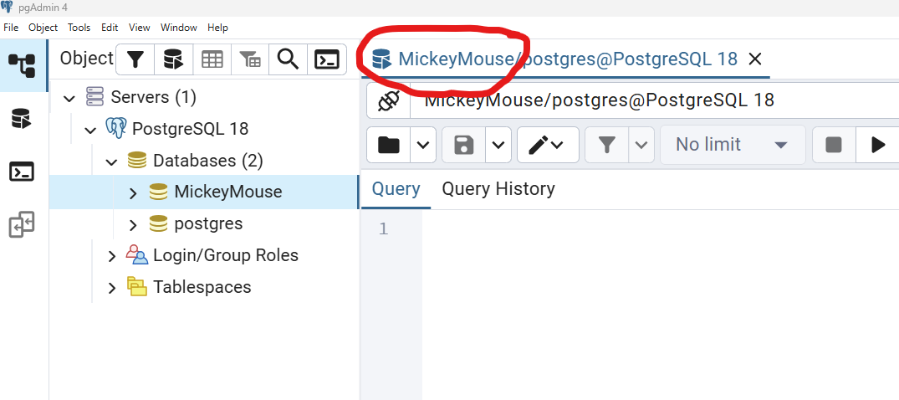
Notice that the database name you are accessing is in the header.

Type your SQL command in the Query Tool. Then press the arrow key or F5 key to execute that command.

